REFERENCE REPORT FOR PUBLICATION
Leonberg, 08/06/2016

"Healing Architecture" defined by GEZE: modern door, window and safety technology in the new Stuttgart Olgahospital with women's clinic

Main entrance to the clinic:
double-leaf automatic
sliding door system as emergency exit
with Slimdrive SL NT-FR drives

The Olgahospital and the women's clinic of the Klinikum Stuttgart have been combined to form one of the most modern and largest centres for paediatric and adolescent medicine and gynaecology in Germany. The new clinic building includes twelve individual clinics, an interdisciplinary emergency ward, numerous outpatient clinics and 385 beds. It was designed by the Stuttgart architectural offices SFP Architekten GmbH and HPP Laage & Partner, with a focus on first-class conditions for medical care and the well-being of the patients. Part of this are the high level of safety and user comfort, the varied functionality and the door and window design fitted with GEZE’s latest door, window and safety technology.

The "Open Sesame Feeling": accessible door comfort with Slimdrive SL NT sliding door systems
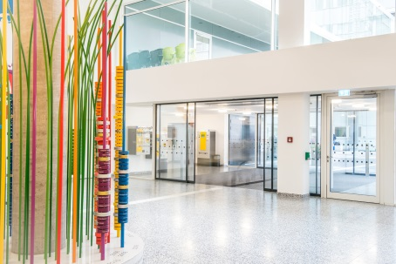

Foyer: automatic sliding door systems in the emergency exit route with narrow, only 7 cm high, Slimdrive SL NT-FR drives
The external facilities and the generous foyer of the new clinic almost merge together unnoticed. An inviting atmosphere is created by the automatic sliding door system, which leads directly to the "arch" as a children's fun and play area. The passage clearance of almost three metres, sleek door profiles and Slimdrive SL NT-FR drives integrated into the ceiling combine accessibility with emergency exit protection and transparency. The double-leaf doors deal with the constantly high public traffic precisely, powerfully and quietly. Their hold-open time adapts to the usage frequency. If the stream of visitors is higher, the door leaves are automatically kept open for longer. In case of danger, the sliding doors ensure free access. Integrated into a metal stele, even the door programme switch has become a design element.
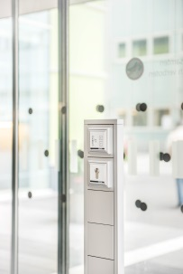

Design element: door programme switch in a metal stele on the automatic sliding door in the foyer

Safety first! Multifunctional doors
Accessibility, non-contact opening, preventive fire protection, emergency exit protection, access control and modern, universal design are the requirements which have to be fulfilled by doors in the clinic. With GEZE system solutions, the most varied function and design requirements were realised in almost a hundred automatic single and double-leaf swing doors.

Slimdrive EMD swing door systems, which are opened via elbow switches or movement detectors, can be found in almost every clinic area.

Slimdrive EMD swing door systems, which are opened automatically by a movement detector when approached, can be found in almost every clinic area. It is also possible to open the doors earlier by activating an elbow switch with a simple touch with the elbow – a great advantage, for example, when you move beds and do not have a free hand. Safety is always guaranteed because the sensor monitoring stops the doors when people are in the swivelling range. The "Push & Go" function, which can be switched on or off, allows the door drive to be controlled by briefly pressing the door leaf.

Double-leaf swing door system with EMD Invers drives as exhaust openings for the natural smoke and heat exhaust ventilation in the case of fire.

When they are integrated into fire alarm systems, double-leaf swing door systems act as escape doors with Slimdrive EMD-F/R-IS drives and as exhaust openings for natural smoke and heat exhaust ventilation in the case of fire with Slimdrive EMD Invers drives. If there is a danger, the alarm command from the fire alarm system also releases the emergency door control TZ 320 so that the doors open automatically. In the event of power failure, the Invers function of the drives ensures automatic opening and hold-open of the doors.

Access to the baby ward is a particularly safety-relevant item. The single-leaf door solution from GEZE combines automatic accessible opening via a Slimdrive EMD-F/R swing door drive system, access control, emergency exit protection in both directions and the automatic opening for fresh air in the case of fire. In automatic mode the door opens at any time for anyone. In night-time operation, the access control system ensures access is only possible for authorised persons. If a dangerous situation requires an evacuation, a fast exit from the ward is possible for everyone. This does not go unnoticed because an alarm is triggered at the same time.

Single-leaf automatic swing doors with Slimdrive EMD-F/R drives also serve as fire protection doors. Slimdrive EMD drive versions are particularly suited for narrow door profiles and for limited space conditions because they are only seven centimetres high. Integrated into the drive cover, the smoke switch does not need any extra space either. The sensor roller guide rail as well as the guide rails and safety sensors are also combined into one element.

Hold-open systems: accessibility for mechanical fire protection doors
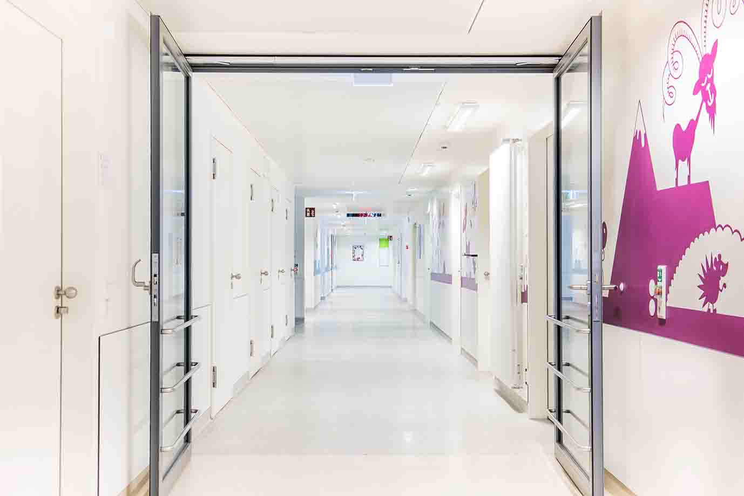

Fire protection door with hold-open system with TS 5000- R-ISM, integrated closing sequence control and lintel-mounted smoke detector for early detection of smoke and fire for the automatic, correct sequence of closing of the door leaves in case of fire.
In almost all wards, single and double-leaf manual fire section doors are held open electromechanically for accessible use by hold-open systems. Compact and attractive, the selected solutions comprise TS 5000 door closers with a comprehensive R-ISM guide rail system, in which all components of the hold-open system are integrated. If a hold-open system has been disabled by a power failure or triggered by a fire detector, the door closers ensure a safe closing of the fire protection door and guarantee the safety function of the fire protection closing.

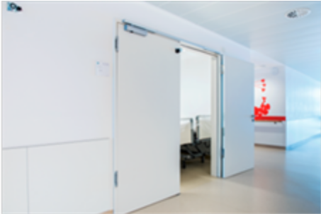

Hold-open systems keep fire protection doors open and close them safely in the event of a fire.
GEZE provides all the components of a hold-open system from a single source.

Hold-open systems can be combined flexibly with safety components. They are also fitted with TZ 320 emergency door controls in the escape and rescue routes. When the emergency push button is activated, the power supply to the emergency exit opener is interrupted and the door opens for everyone. Abuse is also very difficult here since at the same time an optical and acoustic alarm are triggered.

The door control unit TZ 320, heart of the emergency door controls, in combination with a hold-open system

Façade door for natural smoke and gas ventilation. In case of fire, the doors are held open automatically.

Controlled smoke and gas ventilation
On façade doors, too, door closer systems ensure the controlled natural smoke gas exhaust in the case of fire and the safe closure in normal mode. K 600 retractable arm drives in combination with TS 5000 door closers serve as fresh air openings. In the case of fire, the doors are opened automatically and held wide open so that smoke and heat can escape and fresh air is drawn in.

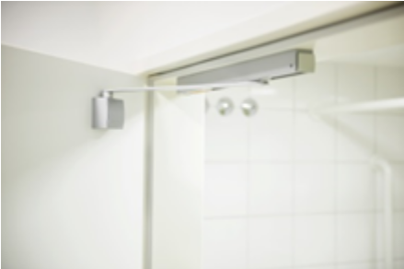
Safety and hygiene with intelligent accessories
Surface-mounted GEZE pivot bearings and T-Stop guide rails are installed in almost all patient rooms. The system with integrated opening restrictor prevents a collision between bathroom door and adjacent room doors and makes floor-fitted door stoppers superfluous. This clever solution not only ensures increased safety, but also improved room hygiene because the floor can be cleaned without interruption.
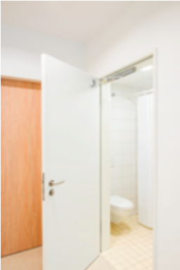

Doors to patients' rooms: Intelligent door technology ensures safety at the door and hygiene on the floor.

Pressekontakt:  Julia Graf  Tel.: +49 (0)7152 203-505  Fax: +49 (0)7152 203-237  E-Mail: j.graf@geze.com | GEZE GmbH  Reinhold-Vöster-Str. 21-29  D - 71229 Leonberg  www.geze.com
ÜBER GEZE
Die Marke GEZE steht für Innovation und Premiumqualität. GEZE gehört zu den Weltmarktführern und ist weltweit ein zuverlässiger Partner bei Produkten, Systemen und Serviceleistungen für Tür-, Fenster- und Sicherheitstechnik. Wie die Anforderungen in einem Gebäude sein mögen – GEZE realisiert optimale Lösungen und verbindet Funktionalität, Sicherheit und Komfort mit Design. GEZE Türschließer eröffnen zahlreiche technische und optische Möglichkeiten. Täglich gehen Millionen von Menschen durch Türen, die mit Obenliegenden Türschließern der TS 5000-Reihe ausgestattet sind, und genießen den Komfort von automatischen Türsystemen, z. B. des Slimdrive-Programms. Barrierefreie Tür- und Fenstersysteme schenken nicht nur mobil eingeschränkten Menschen hohen Komfort. Die Glassysteme und Beschlaglösungen für Design-Schiebesysteme sind Ästhetik pur. Ein breites Produktprogramm bietet GEZE auch im Bereich Fenster- und Lüftungstechnik. Für den vorbeugenden Brandschutz stehen komplette „intelligente“ Rauch- und Wärmeabzugslösungen (RWA) und ein umfassendes Sortiment an Türsystemen als RWA-Zuluftlösungen zur Verfügung. Die GEZE Sicherheitstechnik umfasst Flucht- und Rettungsweglösungen, Schlosstechnik und Zutrittskontrollsysteme. Das GEZE Gebäudemanagementsystem gibt einen Überblick der gesamten Gebäudetechnik. Mit seiner Systemkompetenz realisiert GEZE abgestimmte Lösungen, die einzelne Funktions- und Sicherheitsanforderungen in einem intelligenten System verbinden. Produktlösungen von GEZE sind vielfach preisgekrönt und finden sich in renommierten Bauwerken auf der ganzen Welt wieder. Das Unternehmen ist mit 31 Tochtergesellschaften, davon 27 im Ausland, einem flexiblen und hocheffizienten Vertriebs- und Servicenetz und fast 2.800 Mitarbeiter/innen weltweit vertreten und erzielte im Geschäftsjahr 2014/2015 einen Umsatz von über 366 Mio. Euro. www.geze.com

